**DATA ANALYTICS WITH TABLEAU ASSIGNMENT-2**

**Name : VANITHA KOKKIRIGADDA**

**Roll Number : 23481A4252**

**Branch : CSE(AI&ML)**

**College : SESHADRI RAO GUDLAVALLERU ENGINEERING COLLEGE**

**University : JNTUK**

AIM : The growth of supermarkets in most populated cities is increasing and market competitions are high. The dataset is one of the historical sales of supermarket company which has recorded in 3 different branches for 3 months data.

DONUT CHART :

Title : Sales By Product Line

Rows : AGG(agg(0))

Color : SUM(Total)

Label : Product Line , SUM (Total)

AREA CHART :

Title : Month Wise Total Sales

Columns : DAY(Date)

Rows : SUM(Total)

Color : Branch

TEXT TABLE :

Title : Branch Wise Product Line

Columns : Branch

Rows : Product Line

Label : SUM) Total)

HIGH LIGHTED CHART :

Title : City Wise Rating By Product Line

Columns : QUARTER (Date)

Rows : City , Product Line

Color : SUM(Range)

Label : SUM(Rating)

WORD COUNT :

Title : Product Line By Total Sales

Color : Product Line

Size : SUM(Total)

Label : Product Line

FUNNEL CHART :

Title : Total Rating By Product Line

Rows : SUM(Rating)

Color : Product Line

Size : SUM(Rating)

Label : Product Line , SUM(Rating)

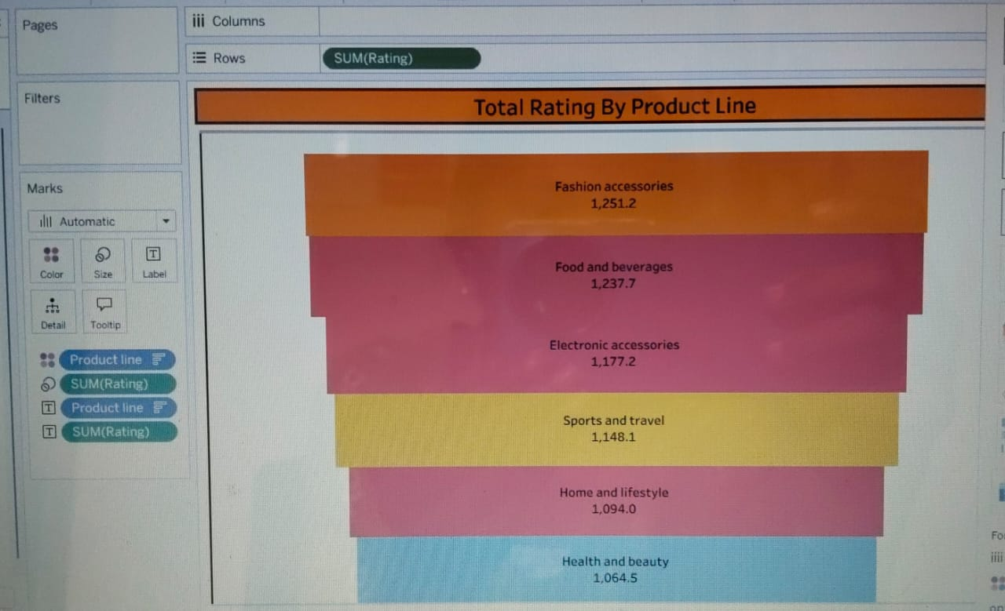

WATER FALL CHART :

Columns : Product Line

Rows : SUM(Quantity)

Color : SUM(Quantity)

Size : AGG(SUM(Quantity))

